Description

In an effort to reduce code collision during merging and do active code cleanup, an eclipse profile has been created that will format classes into a single, cohesive theme. In addition, this will happen on saving the file, so you do not have to remember to execute this. This profile and additional save actions will do the following:

* All tabs will be convert to spaces
  + Tabs can equal a different number of spaces on different systems.
* All declarations will now get properly indented
  + Including the switch statement
* Braces will be added for all if statements, even one liners
* Forces “else if” on a single line
* Line wrappings will now occur after 1000 characters, not 80. So your longer SQL’s and chained actions to not become disheveled.
  + Comments will still wrap after 160 characters to promote readability
* Organize imports
* Remove unused imports
* Remove trailing whitespace on all lines
  + Will help in commit code reviews as extra, accidental spaces count as changes

Importing the Profile

1. The Eclipse profile can be found in the etc folder in the the Chameleon project

1. In Eclipse, go to Window > Preferences
   1. 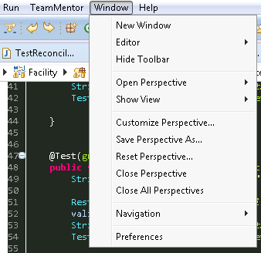
2. In Preferences, got to Java > Code Style > Formatter and click the Import Button
   1. 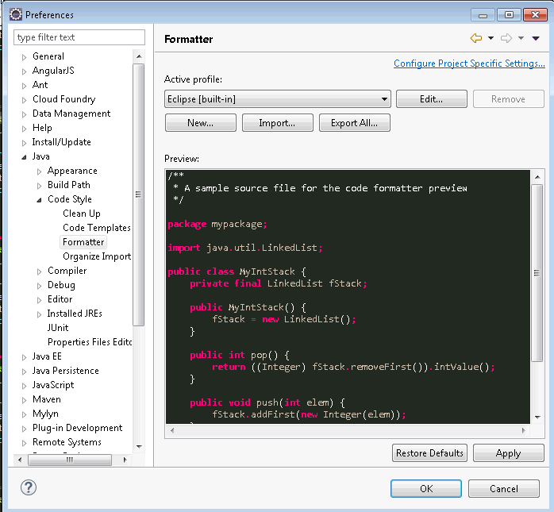

1. Navigate to the etc folder in Chameleon project and import the profile
   1. 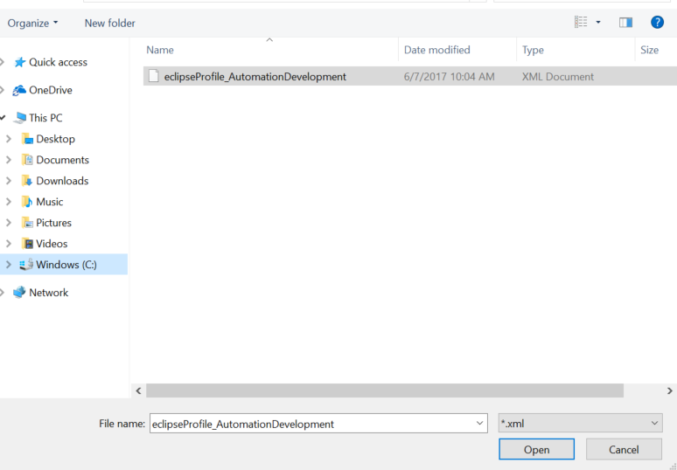
   2. 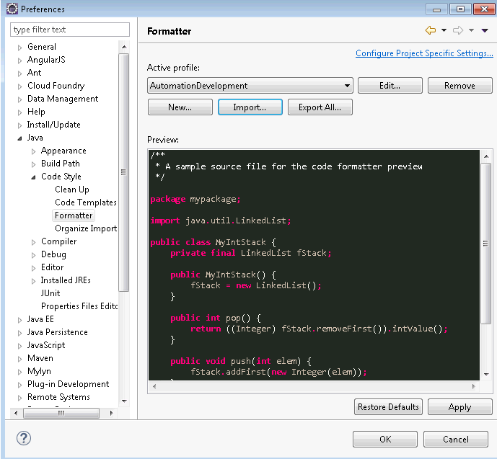
   3. The Active Profile should now be **AutomationDevelopment,** if not, then select it in the Active Profile dropdown.
   4. Click Apply

Creating Save Actions

1. You should still have the Preferences Window up from the last step. If not, go to Window > Preferences in your toolbar
2. Navigate to Java > Editor > Save Actions
   1. 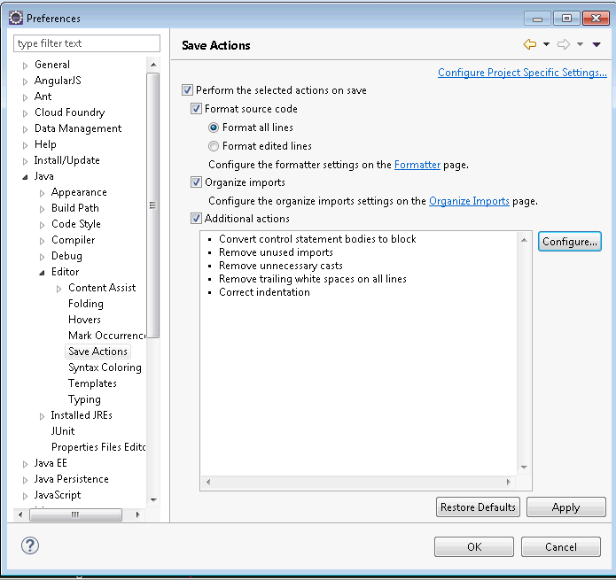
   2. Do not worry if your Save Action do not look like above, it will shortly.

1. Select the following options
   1. Check “Perform the select actions on save”
   2. Select “Format Source Code”
   3. Select “Format All Lines”
   4. Check “Organize Imports”
   5. Check “Additional Actions”
2. Click Configure beside Additional Actions
3. Under “Code Organizing” tab (assume all other options are unchecked or disabled)
   1. Check “Remove trailing whitespace”
   2. Select “All lines”
   3. Check “Correct indentation”
4. Under “Code Style” tab (assume all other options are unchecked or disabled)
   1. Check “Use blacks in if/while/for/do statements”
   2. Select “Always”
5. Under “Member Accesses” tab
   1. All disabled/unchecked
6. Under “Missing Code” tab
   1. All should be selected
7. Under “Unnecessary Code” tab (assume all other options are unchecked or disabled)
   1. Check “Remove unused imports”
   2. Check “Remove unnecessary casts”
   3. Note: we do not want to use “Remove unused private members” as they might be accidentally erased during development and one saves early
8. Click OK to close the window.
9. Save Actions should now have 8 Additional Actions and window look like this
   1. 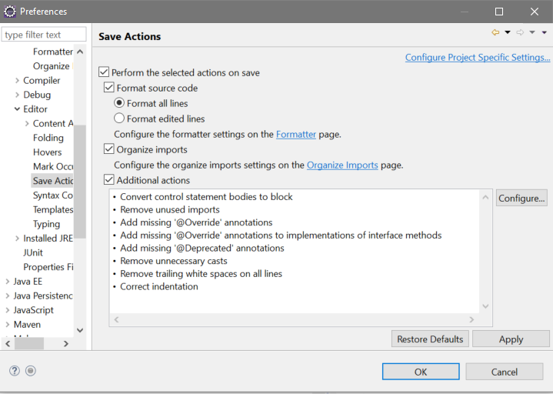

1. Click OK to save and close Preferences Window